# Team Agreement Research

Purpose:

The main purpose of a team agreement is to outline the expectations expected from team members undergoing a particular project together. In this case that project is the creation of a package delivery web application. The specific areas that a team agreement should address are how the team plans to communicate with each other, and how to do that communication effectively. It should also specify the responsibility of the team members in regards to the project. Leadership is a key area that should also be specified as well in a team agreement. A team agreement should also note specific principles that members should adhere to keep the team working effectively. Lastly, the team agreement has to detail consequences for non-compliance of what has been detailed above.

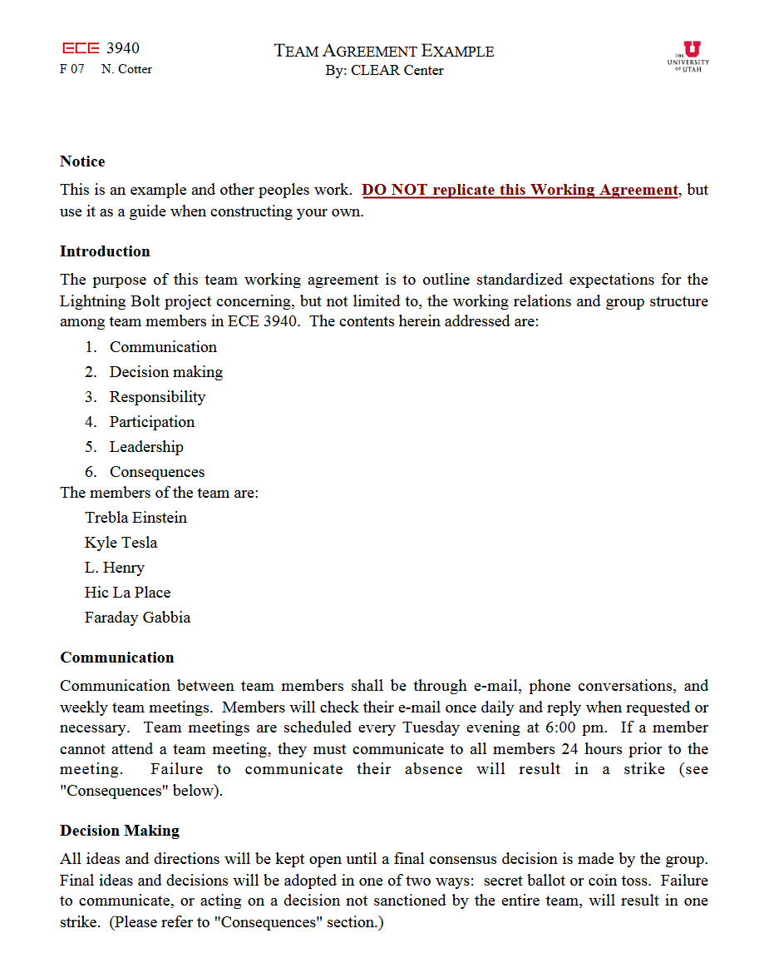

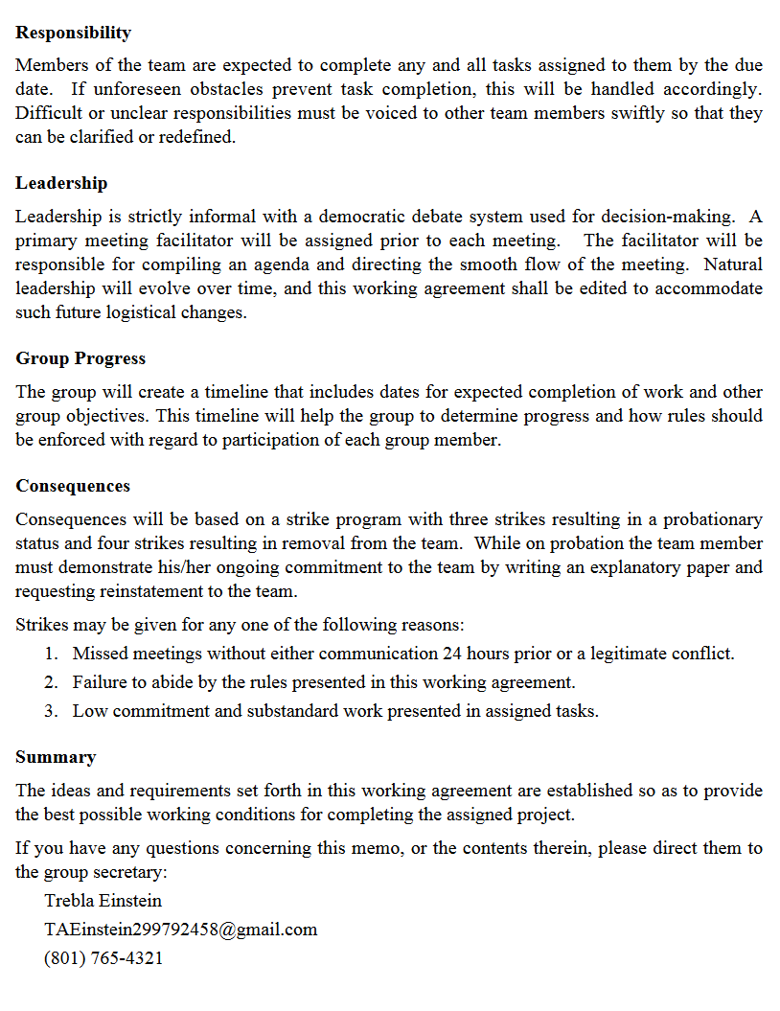

(University of Utah, 2007)

This document details these sections that other optional sections that can be added to a team agreement document. It details specifically how the team will communicate and when team meetings are to be scheduled. Still at communication, it also details that there are specific consequences for not communicating effectively with the other team members. This is important to note as effective communication with in the group is essential to creating an effective project. This is particularly important when two or more team members are working on the same piece of the project; effective communication will prevent work overlap and enable them to assist each other where required.

The document also details the responsibility of the team members, specifically that it is expected of them to complete any tasks assigned to them.

The leadership section of this example team agreement details a democratic approach to leadership where no one person is voted the leader of the team but rather these relationships will evolve naturally throughout the progression of the project. Purposefully voting for a designated leader within a group can have several unintended consequences. The leader within a group tends to have the last word and therefore can be useful to extinguish an ongoing argument. However, at the same time, tensions will rise as the argument never gets worked out naturally; this can negatively effect the effectiveness of the group as a whole. Secondly, if the group members do not know each other that well, voting for a team leader too early may result in a leader that does not have the leadership skills required to keep the group functioning effectively. Having more designated leader allows those with good leadership skills to naturally transition into a leadership role without there ever being a vote.

This example team agreement however does not cover consequences in enough detail for it to be useful for our team’s agreement. It does not have stages and is of a very broad nature.

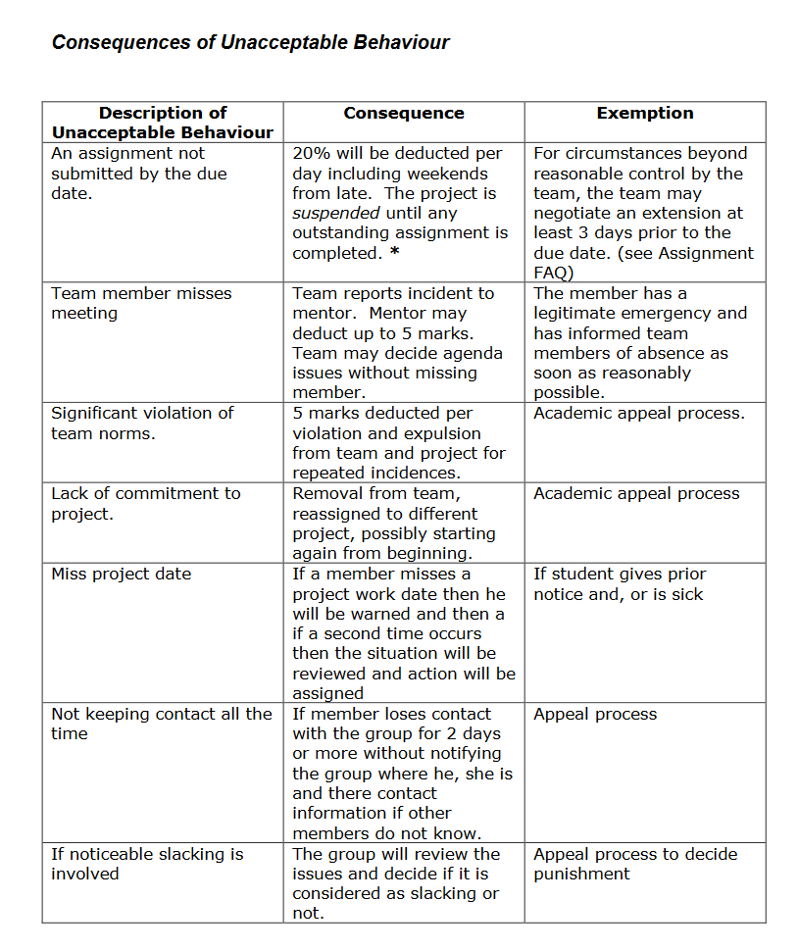

(University of Ontario Institute of Technology, 2012)

This example of a team agreement provides much more specific detail regarding the consequences for not following the team agreement. It notes the description of the behaviour, the consequence and any relevant exemption from the consequences. It is important to have exemptions to consequences as being too strict regarding the enforcement of consequences could have far bigger consequences for the group as a whole than the original behaviour that was deemed acceptable in the first place.

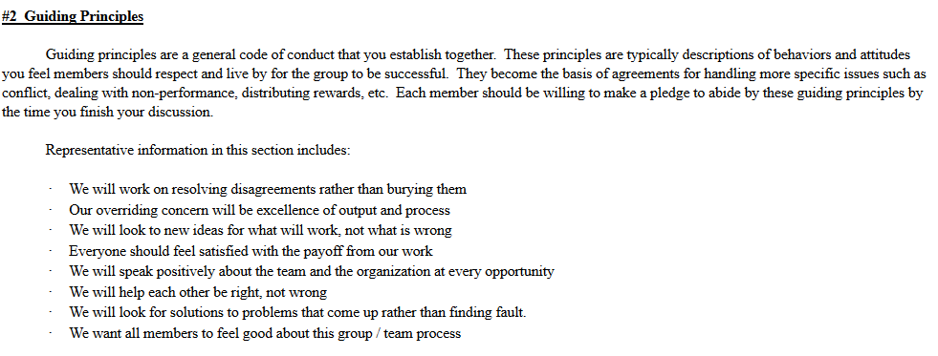

(Tyran, n.d.)

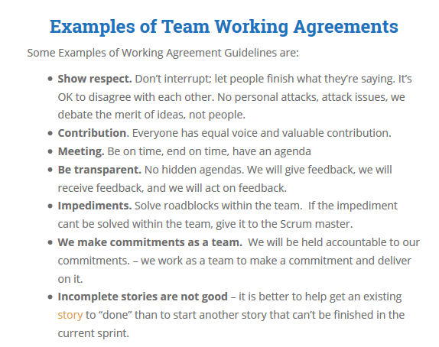

(Payton Consulting, n.d.)

These example team agreements illustrate effective principles to follow for being an effective team. Most of the principles are common sense which is a good foundation to base your team agreement principles on. Principles within a team agreement should be formed in such a way that they make the team work together better by benefiting all members if followed correctly; and not just particular members.

# Bibliography

Payton Consulting, n.d. *Agile Team Working Agreements How To Guide.* [Online]   
Available at: http://www.payton-consulting.com/agile-team-working-agreements-guide/  
[Accessed 2016].

Tyran, D., n.d. *Developing a Team Contract.* [Online]   
Available at: http://faculty.wwu.edu/tyrank/MGMT313/TeamContract313.htm  
[Accessed 2016].

University of Ontario Institute of Technology, 2012. *Team Contract.* [Online]   
Available at: http://apa.uoit.ca/aoda/TeamContract.pdf  
[Accessed 2016].

University of Utah, 2007. *Team Agreement Example.* [Online]   
Available at: http://www.eng.utah.edu/~ece3940/ECE3940F07_TeamAgreeEx.pdf  
[Accessed 2016].